

University of Birmingham, Dubai
School of Computer Science
MSc Data Science
Final Report
LM Data Science Group Project [37858, 32252]
Group 6
Submitted by:
Maryam Kamil 2882517
Hend Al Jaberi 2517184
Aliza Razi 3049919
Sogol Vaghti 2725519

Submitted to:
Dr. Hamid Mukhtar

Abstract 4
1. Research Question Development 5
2. Literature Review 6
2.1 Environmental Factors and Crash Injury Severity 6
2.2 Temporal Patterns in Traffic Injury Risk 6
2.3 Spatial Hotspots and Urban Crash Risk 7
2.4 Gaps in Existing Literature 8
2.5 Contribution of This Study 8
3. Data Collection and Preprocessing 9
3.1 Data Sources 9
3.2 Data Integration and Preprocessing 10
3.4 Borough Imputation Using KNN (Machine Learning) 12
3.5 Traffic Volume Data Processing 13
3.6 Weather Dataset 14
3.7 Construction Permits Dataset 14
4. Dataset Integration & Final Merge 16
4.1 Merge Strategy 16
4.2 Post-Merge Imputation 16
5. Exploratory Data Analysis 17
5.1 Univariate Analysis of Crash Frequency 17
5.2 Severity and Injury Distribution 18
5.3 Crash vs. Traffic Volume Analysis 19
5.4 Weather-Related Crash Analysis 20
5.4.2 Yearly Crash Rate per Hour: Snow vs. No Snow 21
5.6 Feature Engineering 24
6. Data Modelling 26
6.1 Feature Selection 26
6.2. Experimental Results 29
6.3 Cross-Model Comparison 30
6.4 Feature Importance 31
6.5 Hyperparameter Tuning Results 32
6.6 Confusion Matrix Analysis 32
7. Discussion 34
7.1 Model Comparison and Best Model Selection 34
7.2 Effect of Class Imbalance Handling 34
7.3 Feature Importance Findings 34
7.4 Limitations 35
8. Conclusion 37
9. Group Work and Individual Contributions 38
9.1 Group Work 38
9.2 Individual Contribution: Maryam Kamil (2882517) 39
9.3 Individual Contribution: Aliza Razi (3049919) 39
9.4 Individual Contribution: Sogol Vaghti (2725519) 40
9.5 Individual Contribution: Hind Aljaberi (2517184) 40
10. References 41
11. Deepnote Link 43

Abstract
Road traffic injuries are a burning issue of social health and urban safety especially in big metropolises like New York City. It is necessary to understand the causes of traffic crashes in order to come up with effective preventive measures. Although past literature has investigated the effects of single variables (like weather conditions or traffic patterns), not many of the studies have incorporated several sources of urban data in analyzing their overall influence to the risk of crash.
The research will use multiple datasets, such as traffic crash data, weather data, traffic counts, and construction data, to study the environmental and temporal factors risk of road traffic injuries. To standardise and combine these datasets, a set of data preprocessing pipelines were designed to combine the datasets according to their temporal and spatial attributes. The exploratory data analysis was used to reveal the major trends: the changes in the frequency of a crash over time, weather conditions, and traffic density.
Engineering of features was used to extract useful predictors including temporal predictors, weather predictors and infrastructure activity. The features that have been extracted were used to train the predictive models to test the probability of being injured in a road crash based on a particular situation.
This study establishes a pool of variables of traffic injury risk that include the time of the day, weather and road closure incidents. The paper combines both data sources to come up with a holistic method to estimating risk of crash, as well as the promise of data-driven methods of traffic safety in urban areas to plan and make decisions.

1. Research Question Development
The knowledge of the traffic crashes can be achieved only partially without knowing the circumstances that contribute to such crashes, not to mention the variables that influence the severity of such crashes. The literature review revealed an overall tendency of the existence of numerous factors leading to traffic crashes. These factors are usually regarded based on the five exposed route environment categories, time of the day, exposure, and physical road space.
The majority of the research conducted before addressed personal factors affecting the risk of collisions. Weather analysis indicated that e.g. rain and snow increase the risk of crash. Temporal studies have shown that crashes tend to happen on peak hours, this is on the morning and evening peak hours. The other factor is the number of traffic which is measured as a measure of exposure in a number of research studies with the conclusion that the more the traffic density, the higher the probability of crashes.
On the one hand, although the literature has discussed the role of various contributing factors to the occurrence of an accident, no one of the research has addressed the factors as a combination; to be more precise, no research has addressed the factors as a whole. Individual analyses were performed on each of the variables or parameters, i.e. traffic, weather or time of day. Moreover, little attention has been given to the part that is played by the factors related to infrastructure, e.g., a construction activity, that might contribute to traffic and can raise the risk of crashes.
This research gap exists because, in order to explore the combined impacts of multiple environmental, temporal, traffic, and infrastructure factors on traffic injury casualties, this study is aimed at filling this research gap, with the help of multi-source data, which should be integrated to analyze these factors.
Therefore, the primary research question is defined as:
How can environmental and temporal factors be used to predict injury risk levels in traffic crashes, and how can these predictions support the identification of high-risk conditions for proactive traffic safety interventions in New York City?
To support this research question, the following objectives are defined:
- To integrate crash, weather, traffic, and construction datasets into a unified analytical framework
- To explore patterns in crash occurrence using exploratory data analysis
- To develop meaningful features representing environmental and temporal conditions
- To apply machine learning models to predict injury risk levels
- To evaluate how these predictions can inform traffic safety planning

In addition to determining the determining factors, the study will also examine how these variables could be implemented into an early risk warning system, which would allow taking proactive measures, including specific traffic policing, mass media warnings of danger, or resources mobilization in high risk incidents.

2. Literature Review

2.1 Environmental Factors and Crash Injury Severity
Environmental conditions are also generally known as major determinants in traffic crash dynamics and injury outcomes. Poor weather conditions also influence the condition of the roadway surface, perception of the driver, and the control of the vehicle, and this poses unsafe driving conditions. The previous studies have identified road surface traction and visibility impairment as the main mechanisms by which the environmental factors affect the severity of crash injuries (Das et al., 2025).
Precipitation and especially rain and snow narrow down pavement friction, and raises risk of falling and loss of control. Slick and slippery roads increase braking time and decrease the stability in steering, increasing the risk of crashes. The research on winter precipitation shows that snow and ice severely interfere with traffic processes and make the frequency of collisions more frequent (Black and Mote, 2015). Moreover, surface roughness and water pool formation are other pavement conditions that may contribute to these risks by causing hydroplaning and decreasing the skid resistance (Sadeghi and Goli, 2024).
Crash consequences are also influenced by environmental factors such as diminished visibility and perception of the driver. Mist, precipitation, and snowstorms restrict the capacity of drivers to observe hazards and react appropriately, therefore, raising the likelihood of collision. Such effects are especially high in high-speed or high-density traveling conditions. Studies repeatedly name visibility impairment as one of the primary factors of serious crashes, particularly when it is accompanied by the nighttime driving environment (Das et al., 2025).
In addition to the probability of a crash, the environmental conditions affect the severity of injury. The adverse weather conditions are linked to the higher-impact and multi-vehicle collisions causing more injuries. As an example, precipitation during winter has been associated with a high increase in crashes associated with injuries when compared to dry seasons (Black and Mote, 2015). In general, unfavorable environmental factors enhance the dynamics of the crash and decrease the capability of the drivers to reduce the risk, making injuries more severe.

2.2 Temporal Patterns in Traffic Injury Risk
The temporality is a very important factor that influences the occurrence and injury results of traffic crashes. The differences in traffic demand, driver conduct, and environmental circumstances over time result in dissimilar injury risk patterns. Available literature refers to time of day, day-of-week travel behavior, and seasonal variation as some of the most important determinants of crash risk over time.
There is a high difference in crash risk among the hourly traffic cycles. The highest risk in terms of injuries is usually caused by people during their commuting time, especially in the morning and evening, when traffic is greatest and the urgency to travel is the most intense (Tang et al., 2024). The evening hours also pose further danger because of fatigue and lack of visibility. Research indicates that crash incidences are not randomly distributed but in clusters in time, and there are defined high-risk periods (Liu and Sharma, 2017).
Injury risk is also determined by weekly travel patterns. Weekdays themselves are linked to increased frequencies of crashes because of organized commuting patterns and peak-hour flows, whereas weekends tend to indicate alternative behavioral patterns such as leisure travel and mobility during the night. These differences emphasize the need to consider the changes in time when examining the crash risk (Tang et al., 2024).
Another contributing factor to the risk of crash injuries is seasonal variation. Varied weather conditions, availability of daylight and travel patterns in different seasons lead to the variations in crash patterns. Specifically, the weather is unfavorable and visibility could be low, which makes the risk of accidents more severe in winter. The longitudinal studies prove the existence of repeat temporal patterns and highlight the importance of using seasonal dynamics to model the risk of injury (Liu and Sharma, 2017).

2.3 Spatial Hotspots and Urban Crash Risk
To get a glimpse of the geographic distribution of traffic crash injuries, spatial analysis is inevitable. The crash incidents are not randomly scattered but are usually concentrated in certain areas like major roadway systems, crossroads, and other business highways. Geographic Information Systems (GIS) can be efficient means of discovering these injury hotspots and facilitating specific safety interventions. Research indicates that serious impacts of crashes are confined in regions with vast traffic flows, intricate road geometries, and higher human populations (Dai, 2012).
The methods of hotspot detection allow identifying long-term high-risk areas that are of key importance in the priority of infrastructure upgrades and implementation policies. Spatial risk is also affected by environmental and temporal factors. Studies show that crash hotspots change over time and weather conditions that manifest the dynamic variation of traffic demand and exposure (Perrels et al., 2015). The findings emphasize the significance of the combination of spatial, temporal, and environmental data to reflect the patterns of injury risks more effectively.
Besides the permanent infrastructure features, temporary disturbances like construction zones provide local risk. Roadwork works change traffic movement by closing lanes, deterring, and decreasing the road capacity, which makes roads more congested and prone to collisions. Research shows that this type of interference may cause driver confusion and rapid deceleration, which add to the number and the severity of the crashes (Wang and Chen, 2016). The current studies also indicate that construction areas have been linked to an increased likelihood of serious crash consequences because of limited manipulability and the flexibility in speed (Hassandokht Mashhadi et al., 2025).

2.4 Gaps in Existing Literature
Even though a large amount of research has been done on the risk of traffic crashes, there are still a number of limitations. The major gap is the disaggregated analysis of risk factors of injury, in which the environmental, temporal and spatial factors are normally analyzed in isolation, instead of in a cohesive framework. This reduces the capacity to adequately address all the intricate interactions that determine the level of crash injuries.
Furthermore, the literature tends to ignore the importance of temporary built environment disturbances, including construction areas, in determining risk of crash. Although spatial analyses place permanent high risk sites, they rarely consider dynamic changes in infrastructure that can bring about short term risk variations.
These loopholes indicate the necessity of a holistic, evidence based methodology that encompasses various variables in order to enhance the accuracy and generalizability of models of injury risk prediction.

2.5 Contribution of This Study
This research fills the research gaps by formulating a composite analytical construct that incorporates environmental, time, space and infrastructure elements to forecast the severity of traffic crash injuries. The multi source data incorporation enables the research to capture the complex interaction between these variables and increases prediction accuracy.
The research also incorporates further spatial analysis with construction-related disruption as dynamic risk factors. This will allow a more detailed interpretation of the impact of temporary infrastructure changes on crash results.
Lastly, the results can be used to advocate proactive traffic safety measures by establishing high-risk areas and times. The method ensures easier allocation of resources, focused enforcement, and urban safety planning based on data.

3. Data Collection and Preprocessing
The study has integrated findings of several sources to discuss the effect of environmental and temporal factors on the likelihood of traffic injury to take place in New York City. Since the data was obtained through various sources, thus, differed in data format, qualities, resolutions, and characteristics, a structured approach of cleaning and integration of data needed to be used to prepare the data to be analysed.

3.1 Data Sources
Four datasets were collected, cleaned, and integrated to form the analytical foundation of this study. Each dataset covers the period 2015-2025, where available, and captures different dimensions of traffic crash risk.

3.1.1 Motor Vehicle Collisions Dataset (NYC Open Data)
This is the main data set. It includes a tremendous amount of information about crashes; who was involved, when it occurred, where it occurred and extent of injuries.
Field | Detail
Rows (raw) | 2,239,103
Columns | 29
Date range used | 2015-01-01 to 2025-12-31
Rows after filter | 1,562,065
Key columns | CRASH DATE, CRASH TIME, BOROUGH, LATITUDE, LONGITUDE, injury/kill counts
Missing (key) | BOROUGH: 439,752  LATITUDE/LONGITUDE: 160,296

3.1.2 Weather Dataset (Open Meteo)
Shows current hourly weather data such as temperature, humidity, precipitation, snowfall, cloudiness and wind speed.
Field | Detail
Source | open-meteo-40.74N74.04W51m.xlsx
Coverage | Hourly observations, NYC coordinates (40.74°N, 74.04°W)
Key columns | temperature_2m (°C), relative_humidity_2m (%), rain (mm), snowfall (cm), cloud_cover (%), wind_speed_10m (km/h)

3.1.3 Traffic Volume Dataset (NYC DOT)
Contains traffic sensor data measuring vehicle flow across different parts of the city.

Field | Detail
Rows (raw) | 1,838,386
Columns | 14 (+ 1 engineered DATE column)
Years covered | 2000–2025 (filtered to 2015–2025)
Rows after filter | ~1,032,352
Key columns | Boro, Yr, M, D, HH, MM, Vol, street, fromSt, toSt, Direction
Missing values | toSt: 1,246 | All other key fields complete

3.1.4 Construction Activity Dataset (NYC Department of Buildings)
Includes records of construction projects, providing information about infrastructure activity over time.
Field | Detail
Source | NYC Open Data API – ic3t-wcy2
Fetched via | Paginated API calls (50,000 rows per page)
Key columns | job__, job_type, borough, gis_latitude, gis_longitude, pre__filing_date, signoff_date
Each dataset explores a different facet of crash risk, from environmental conditions to levels of exposure and the physical landscape of urban areas.

3.2 Data Integration and Preprocessing
Due to the use of multiple datasets, extensive preprocessing was required to ensure consistency and enable integration.
The main preprocessing steps included:
- Unnecessary columns were removed to reduce complexity and focus only on relevant variables.
- Datatypes were standardized:
  - Date and time columns were converted into datetime format
  - Numerical variables were properly formatted for analysis.
  - Borough names were cleaned by converting them to lowercase and removing extra spaces to ensure consistency across datasets.
- Missing values were handled.
  - Missing construction activity values were replaced with zero, assuming no construction occurred.
  - Missing borough values in the crash dataset were later handled using a spatial imputation approach.
  - The traffic data gap was handled by aggregation.
These steps ensured that the datasets could be merged without errors and that the analysis would be reliable.

3.3. Motor Vehicle Collisions Dataset Processing
The crash dataset was loaded and inspected using pandas. A data type warning in the ZIP CODE column indicated mixed formats, requiring type standardization.
Observation | Detail
Raw shape | 2,239,103 rows × 29 columns
Missing BOROUGH | 562,255 rows (~25%)
Missing LATITUDE | 240,564 rows
DtypeWarning column | ZIP CODE (mixed int/str)

3.3.2 Date and Time Processing
Temporal variables were converted into datetime format to enable filtering and feature extraction.
crash_df['CRASH DATE'] = pd.to_datetime(crash_df['CRASH DATE'], errors='coerce')
crash_df['CRASH TIME'] = pd.to_datetime(crash_df['CRASH TIME'], format='%H:%M', errors='coerce').dt.time

3.3.3 Date Filtering (2015–2025)
Only records from 1 January 2015 to 31 December 2025 were retained. A YEAR column was added for grouping.
df_filtered = crash_df[(crash_df['CRASH DATE'] >= '2015-01-01') & (crash_df['CRASH DATE'] <= '2025-12-31')].copy() df_filtered['YEAR'] = df_filtered['CRASH DATE'].dt.year

3.3.4 Removal of Non-informative Records
Rows entirely missing all spatial and street information AND having zero casualties were identified as non-informative and removed. The removal condition required ALL of the following to be true simultaneously:
- BOROUGH, ZIP CODE, LOCATION, ON/CROSS/OFF STREET NAME all null
- LATITUDE and LONGITUDE null or equal to zero
- NUMBER OF PERSONS INJURED null or zero
Step | Result
Rows before removal | 1,722,361
Rows removed* | 8,991
Rows after removal | 1,713,370
*all the unnecessary columns are dropped to reduce the dimensionality of the data and to choose only the important features.

3.3.5 Removal of Missing Coordinates
Records where LONGITUDE or LOCATION were null were removed, as they cannot be spatially analysed and would cause failures in the KNN imputation step.Values missing in the borough column in the crash dataset are filled using spatial imputation.
Step | Result
Rows before | 1,713,370
Rows removed | 151,305 (no coordinates)
Rows after | 1,562,065

3.4 Borough Imputation Using KNN (Machine Learning)
After coordinate cleaning, 439,752 records (28%) still had no BOROUGH label. Rather than discarding these records, which would introduce systematic bias, a supervised machine learning approach was adopted to recover the missing labels.
Motivation
NYC's five boroughs have distinct, non-overlapping geographic footprints. Because every remaining record already had valid latitude/longitude coordinates, the borough label can be reliably inferred from location alone, a task perfectly suited to a spatial classifier.
Methodology
- Split data into train_df (known BOROUGH) and test_df (missing BOROUGH).
- Used LATITUDE and LONGITUDE as the sole input features (X).
- Encoded the target BOROUGH as integers using LabelEncoder.
- Trained a KNeighborsClassifier with k=5 on the training set.
- Predicted borough labels for all missing records and wrote them back into df_filtered.
Validation & Result
To validate the model, an 80/20 train validation split was applied on the known borough subset:
Validation Accuracy: 99.56%
KNeighborsClassifier (k=5) · Features: LATITUDE, LONGITUDE

This extremely high accuracy is expected because boroughs are geographically non-overlapping polygons; latitude/longitude is nearly a deterministic predictor of borough membership. All 439,752 missing BOROUGH values were successfully recovered.

3.5 Traffic Volume Data Processing
The automated traffic volume dataset was separately cleaned and prepared for integration with the crash data.

3.5.1 Cleaning Steps
- Loaded CSV; addressed DtypeWarning on the Vol (volume) column caused by mixed numeric/string entries.
- Inspected data: 1,838,386 rows, 14 columns, 21 unique years (2000–2025).
- Constructed a unified DATE column by assembling the Yr, M, D integer fields into a proper datetime.
- Filtered to the target date range (2015–2025).
- Dropped SegmentID, WktGeom, RequestID, spatial geometry and identifier columns not needed for analysis.
- Converted Vol to numeric type with error coercion; created Traffic_Category using quantile binning.
Field | Detail
Rows before filter | 1,838,386
DATE range after filter | 2015-01-04 to 2025-12-11
Missing values | toSt: 1,246 | All other analytical fields complete
Final columns | Boro, Yr, M, D, HH, MM, Vol, street, fromSt, toSt, Direction, DATE, Traffic_Category

3.5.2 Traffic Volume Aggregation
For merging with crash data, traffic volume was aggregated by borough, day-of-week, and hour to create a representative traffic_volume feature:
traffic_borough_hour = ( au.groupby(['Boro','day_of_week','HH'])['Vol'] .mean() .reset_index(name='traffic_volume') )

3.6 Weather Dataset
Hourly weather observations from Open-Meteo covering NYC coordinates were cleaned and standardised for joining with crash records.

3.6.1 Cleaning Steps
- Removed unnamed index columns produced by Excel export.
- Parsed the time column to datetime; extracted date and hour fields.
- Coerced all six numeric weather columns to float with error handling.
- Engineered a season column (Winter/Spring/Summer/Fall) from the month.
- Removed duplicate date-hour combinations prior to merging.

3.6.2 Final Weather Columns Retained
Column | Description
date | Calendar date (datetime)
hour | Hour of observation (0–23)
season | Winter / Spring / Summer / Fall
temperature_2m (°C) | Air temperature at 2m height
relative_humidity_2m (%) | Relative humidity at 2m height
rain (mm) | Rainfall accumulation
snowfall (cm) | Snowfall accumulation
cloud_cover (%) | Cloud cover percentage
wind_speed_10m (km/h) | Wind speed at 10m height

3.7 Construction Permits Dataset
NYC DOB construction permit data was fetched via the Socrata Open Data API in paginated batches of 50,000 rows, then cleaned and engineered into a time-series of active construction activity by borough and date.

3.7.1 Data Fetching
Due to computational reasons the columns were directly selected from the url as the dataset had a lot of columns which were not in use for this study. Selected only the 7 required columns (job ID, type, borough, coordinates, start date, end date).

3.7.2 Cleaning Steps
- Stripped and uppercased job_type; grouped into 4 categories: Alteration, New Building, Demolition, Other.
- Renamed pre__filing_date → construction_start; signoff_date → construction_end.
- Parsed both date columns to datetime; removed rows without a construction_start date.
- Filled missing construction_end with construction_start (same-day project assumption).
- Standardised borough and job_type_group to lowercase stripped strings.

3.7.3 Active Construction Time-Series Engineering
Construction activity was derived using project start and completion dates.
Two daily variables were created:
- Start count: number of projects starting each day
- End count: number of projects completed each day
Using these, active construction was calculated as:
Active Construction = cumulative starts − cumulative ends
This represents the number of ongoing construction projects at any given time.
Construction types were also grouped into broader categories (e.g., alteration, demolition, new building) and converted into numerical features.

4. Dataset Integration & Final Merge
The four cleaned datasets were merged sequentially on date, hour, and borough keys to produce a single unified analytical dataset.

4.1 Merge Strategy
Step | Datasets | Join Keys
Step 1 | Crash + Weather | Left join on [date, hour]
Step 2 | + Traffic Volume | Left join on [day_of_week, hour, BOROUGH]
Step 3 | + Construction | Left join on [date, BOROUGH]

4.2 Post-Merge Imputation
After merging, a small number of null values remained in contextual features (traffic volume and construction counts for records outside data coverage). These were filled with zero as a conservative assumption:
merged_df['active_construction'] = merged_df['active_construction'].fillna(0) merged_df['start_count'] = merged_df['start_count'].fillna(0) merged_df['end_count'] = merged_df['end_count'].fillna(0) merged_df['construction_change'] = merged_df['construction_change'].fillna(0)

5. Exploratory Data Analysis
Exploratory Data Analysis (EDA) serves two complementary purposes in this study: it validates the data cleaning decisions documented in Section 2 by confirming that the cleaned dataset exhibits internally consistent distributions, and it generates the empirical hypotheses that guide feature engineering and model selection in subsequent sections. The analysis is organised into three tiers, univariate, temporal, and multivariate, and is further stratified by thematic domain (spatial, weather related, construction related).

5.1 Univariate Analysis of Crash Frequency
Univariate stage is the analysis of marginal distribution of the number of crashes on the major directions of time and space. Each of the annual crash volumes, hourly crash profiles, seasonal cycles, and borough level totals are checked individually and not until cross dimensional interactions are introduced.

5.1.1 Annual Crash Trend
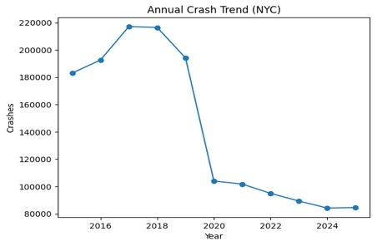
The dataset spans 2015 to 2025. Crash volumes peaked in 2018 (231,564 records) before declining sharply in 2020, coinciding with pandemic-related mobility restrictions. Volumes continued to contract through 2025, suggesting a structural shift in travel demand rather than a transient shock.
Figure 5.1.1 – Annual Crash Trend (NYC, 2015–2025). Crash counts peaked in 2018 and declined sharply from 2020 onward.

5.1.2 Total Crashes by Borough
Brooklyn and Queens together account for the majority of all recorded crashes, reflecting their large road networks and population densities. Staten Island records the fewest crashes in absolute terms.
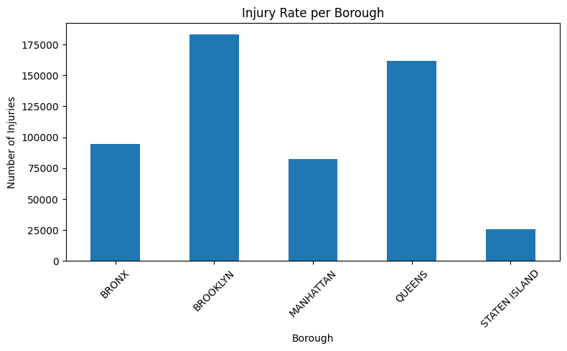
Figure 5.1.2– Total Crashes by Borough

5.2 Severity and Injury Distribution
Beyond raw crash counts, the analysis examines the distribution of injury outcomes across road user types and time periods to identify which segments of the network and which hours carry the greatest human cost.

5.2.1 Injury Distribution by Road User Type
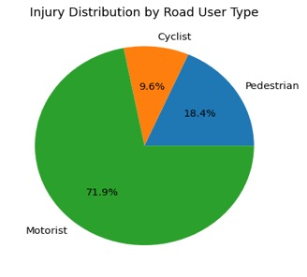
Motorists constitute the largest share of injured persons, followed by pedestrians and cyclists. The proportions underscore the vulnerability of non-motorised users relative to their share of total crashes.

5.3 Crash vs. Traffic Volume Analysis
This subsection integrates the crash dataset with the Automated Traffic Volume Counts dataset to assess whether higher traffic volumes at a location or time of day systematically increase crash probability.

5.3.1 Injury Rate per Borough
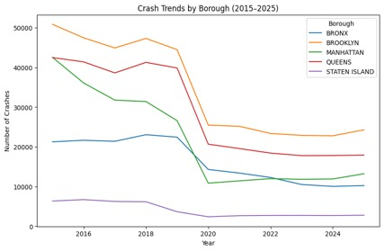
When injuries are normalised by crash count, the ranking of boroughs shifts relative to raw totals, suggesting that some boroughs have higher severity crashes even where absolute volumes are lower.
Figure 5.3.1 – Injury Rate per Borough. Total injuries by borough reflect both crash frequency and localised severity factors.

5.3.2 Traffic Volume vs. Number of Crashes
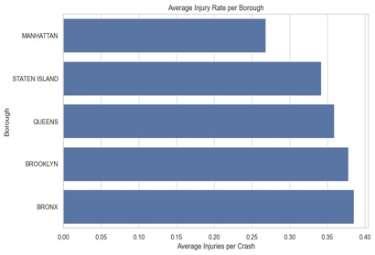
The scatter plot of annual traffic volume against annual crash count reveals a positive but non-linear association: crash numbers do not scale proportionally with traffic, suggesting diminishing returns at very high volumes.
Figure 5.3.2 – Traffic Volume vs. Number of Crashes.

5.4 Weather-Related Crash Analysis
The weather sub-analysis merges hourly meteorological observations with crash records to quantify the influence of precipitation, temperature, and snow on crash frequency and severity.

5.4.1 Average Injuries by Rain Intensity
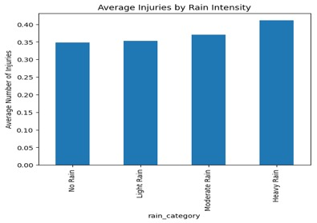
Average injuries per crash rise monotonically from No Rain through to Heavy Rain, with heavy rainfall associated with roughly 18% more injuries per crash than dry conditions, confirming a dose response relationship.
Figure 5.5.1– Average Injuries by Rain Intensity. Injury rates increase progressively with rainfall intensity.

5.4.2 Yearly Crash Rate per Hour: Snow vs. No Snow
Crash rates per weather hour during snow conditions consistently exceed those during dry conditions across all study years, with a pronounced gap in years of above-average snowfall.
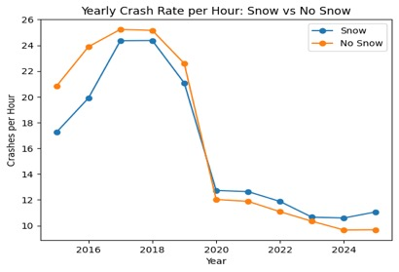
Figure 5.4.2 – Yearly Crash Rate per Hour:

5.4.3 Average Crashes per Day by Season
Daily crash rates are highest in Autumn and lowest in Winter on a per-day basis, echoing the univariate seasonal finding and confirming that exposure reduction in Winter offsets the higher per trip risk.
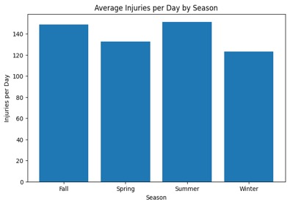
Figure 5.4.3– Average Crashes per Day by Season. Autumn leads in daily crash rate; Winter shows the lowest daily average.

5.5 Construction Activity vs. Crash Analysis
The final thematic domain explores whether construction activity proxies for additional road hazards. The analysis is restricted to 2015-2020, the period for which construction permit coverage in the NYC DOB dataset exceeds 1,000 records per year.

5.5.1 Construction Starts per Year
Construction starts declined from 2015 to 2019 before a brief 2020 rebound, after which coverage thinned markedly. The 2015-2020 restriction is therefore data driven rather than arbitrary.
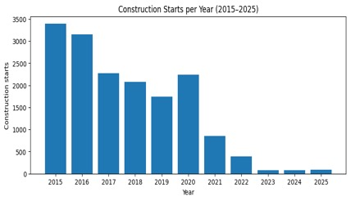

Figure 5.5.1 – Construction Starts per Year (2015–2025). Data coverage is reliable only through 2020.

5.5.2 Monthly Construction Starts by Borough
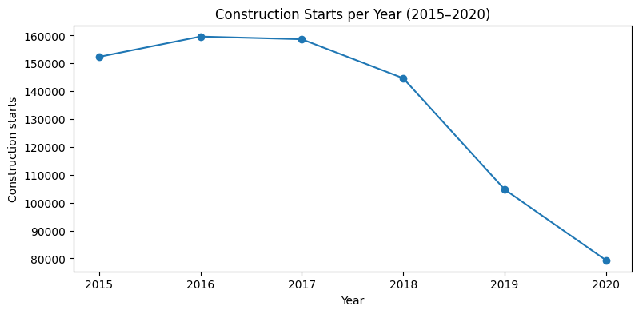
Manhattan consistently leads in construction starts per month, followed by Brooklyn and Queens. The pattern suggests that Manhattan's dense built environment generates sustained permit activity, while outer boroughs show stronger seasonal swing.
Figure 5.5.2 – Monthly Construction Starts by Borough (2015–2020).

5.5.3 Crashes and Construction Starts per Year
Annual crash and construction-start series move broadly in parallel through 2019. The 2020 divergence, crashes falling sharply while construction rebounded, confirms that pandemic mobility suppression, not construction, was the primary driver of the crash decline.
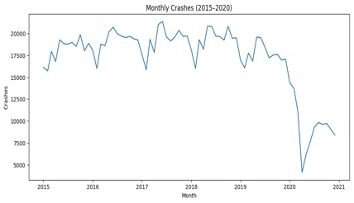

Figure 5.5.3.1 – Crashes per Year (2015–2020). Pre-pandemic trends track construction activity.

5.5.4 Crashes by Borough (2015–2020)
Brooklyn records the highest absolute crash count during the overlap period, while Manhattan leads in construction starts. The inverse ordering implies that crash density is more sensitive to road-network characteristics and traffic volume than to permit activity alone.

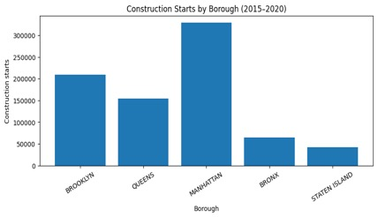
Figure 5.5.4.1 – Crashes by Borough (2015–2020). Brooklyn leads crashes; Manhattan leads construction starts, confirming different underlying drivers.

5.6 Feature Engineering
Structured features were derived regarding the existing variables in the four datasets after data cleaning and integration. There was no introduction of external data.
Temporal characteristics were also obtained based on crash date and time to describe trends in the number of crashes such as year, month, hour, day of the week, season, rush hour indicator, weekend indicator, and night flag.
A dichotomous severity criterion was developed to be classified as severe (1) when at least one injury or fatality was present, and not severe (0) otherwise. The variables of injury and fatality were not considered as a model input to avoid leakage of data.
The weather conditions were reduced to binary flags (rain snow high wind) and a categorical variable of season to reflect how bad weather influences the crash outcomes.
Start and end dates of projects were used to obtain construction activity. The number of projects under construction was calculated as cumulative construction projects less cumulative construction projects calculated at a given period. There were four categories of permits, namely, alteration, new building, demolition and other.
Aggregations at the borough- hour-day of week level of traffic were carried out based on the average sensor readings, matching the crash data to the traffic data, and retained the spatial and temporal variation.


Final Dataset Before Modeling

6. Data Modelling
This section describes an entire machine learning pipeline to the severity of traffic crash injuries prediction on New York City data. We will take up the procedure of evaluation of the most favorable arrangement of features, class imbalance, training, and selection of the most favorable running models of Random Forest, XGBoost, and logistic Regression. Each of the models was trained using 1,562,065 crashes and tested using 312,413 crashes.

6.1 Feature Selection
After data preprocessing and feature engineering, 31 input features were extracted to train the models. The standard set of columns from the data were augmented with additional engineered features to better capture time-related information, weather, and construction activity information.
The following columns were excluded to prevent data leakage:
• NUMBER OF PERSONS INJURED and KILLED - directly used to construct the target variable
• Sub-category injury/killed columns (pedestrians, cyclists, motorists)
• CRASH DATE and CRASH TIME - replaced by engineered temporal features
• LOCATION - redundant given LATITUDE and LONGITUDE
• ZIP CODE - redundant given BOROUGH and spatial coordinates
• CONTRIBUTING FACTOR VEHICLE 1/2/3 - high missing value rate
• VEHICLE TYPE CODE 1/2/3 - not relevant to study focus

6.1.1 Output Feature Selection
The target variable is Severity was engineered as a binary classification label :
- Severe (1): At least one person was injured or killed (NUMBER OF PERSONS INJURED ≥ 1 OR NUMBER OF PERSONS KILLED > 0).
- Not Severe (0): No injuries or fatalities were reported.
Class | Records | Percentage
0 — Not Severe | 1,152,790 | 73.8%
1 — Severe | 409,275 | 26.2%
Total | 1,562,065 | 100%
Table 6.1.1: Class distribution of the SEVERITY target variable
The ratio of class frequencies is 73.8%/26.2% which is moderately imbalanced; for handling class imbalances please refer to Section 5.4.
The 73.8/26.2 class ration shows a moderate class imbalance that will be addressed through handling techniques.

6.1.2 Rationale behind Model Selection
In this project,three methods were trained on the data, a simple linear regression, as well as two different ensemble methods based on Gradient Boosting. The selection was guided by the dataset characteristics which are 1.2 million rows, 31 mixed features, and a moderate class imbalance as well as computational constraints on Google Colab.
- Logistic Regression (Baseline): Simple to understand and fast to train, but has a limited capacity as it is bound by a linear decision boundary.
- Random Forest (Advanced): An ensemble learning method for tree constructers to learn from non-linear relationships. In this example the function only goes up to 80 estimators because there is not enough RAM.
- XGBoost (Advanced): Enhanced sequential gradient boosting algorithm, incorporates balance for classification (using scale_pos_weight), and enables efficient construction of histograms on large datasets, and is considered state-of-the-art for large-scale problems of this type.
Model | Type | Advantages | Limitations
Logistic Regression | Baseline | Fast, interpretable, efficient on large data | Assumes linearity, limited with complex patterns
Random Forest | Advanced | Non-linear, feature importance, robust | RAM intensive, limited to 80 trees
XGBoost | Advanced | Memory efficient, native imbalance handling, sequential boosting | More hyperparameters to tune
Table 6.1.2: Summary of model selection rationale

6.1.3 Handling Imbalanced Data
The dataset has a class imbalance of 73.8%/26.2% between non-severe and severe crashes. Without addressing this imbalance, models would predominantly learn to model the majority class of non-severe crashes, resulting in a poor ability to detect severe crashes. Two strategies were employed to address this imbalance.
Class Weighting: This technique penalizes the model more for misclassifying minority class samples. For the Logistic Regression and Random Forest models, the class_weight parameter was set equal to “balanced” which automatically sets the weights to inversely proportional to the class frequencies. For XGBoost, the scale_pos_weight parameter was set to 2.82 which is the ratio of the number of negative training samples to positive training samples (922,232 / 327,420).
SMOTE (Synthetic Minority Oversampling Technique) works by generating synthetic examples within the minority class by interpolating between existing samples and/or k-nearest neighbours. Due to the size of the dataset, SMOTE was applied to a reduced 200,000 record training dataset (from which test cases are subsequently generated). The k_neighbors was set to 3 and sampling_strategy set to 0.5. SMOTE is only applied to the training set and never to the test set in order to avoid data leakage.
Class | Before SMOTE | After SMOTE
0 — Not Severe | 147,689 | 147,689
1 — Severe | 52,311 | 73,844
Total | 200,000 | 221,533
Table 6.1.3: SMOTE sample - class distribution before and after oversampling

6.1.4 Data Split and Feature Scaling
To evaluate the performance of the approach an 80/20 split was performed, which maintained a 73.8/26.2% class ratio in both the training and test data.
Set | Records | Percentage
Training Set | 1,249,652 | 80%
Test Set | 312,413 | 20%
Total | 1,562,065 | 100%
Table 6.1.4: Training and test set sizes after stratified 80/20 split

6.1.5 Logistic Regression
We first trained a Logistic Regression and used it as a baseline classifier by employing two different imbalance strategies, i.e., class_weight=‘balanced’ and SMOTE oversampling. The results obtained are reported in Section 6.

6.1.6 Random Forest
We utilised a Random Forest approach to train and test our classification models. Class_weight='balanced' and SMOTE were utilised. The number of estimators were restricted to 80 due to RAM limitations on Google Colab. Results are then discussed in Section 6.

6.1.7 XGBoost
The XGBoost model was trained with two different imbalance strategies: using scale_pos_weight with a weight value of 2.82 (922,232/327,420) and with SMOTE oversampling. This helped the learning process because the use of tree_method='hist' on the large training set of 1,200,000 rows helped to save memory. XGBoost has an especially robust method for building trees in that the trees are constructed sequentially where each tree tries to correct the errors made by the previous tree, which results in a very effective learning model for complex classification. More model results are compared in Section 6.

6.2. Experimental Results
This section provides full experimental results for all six models. Results include individual model performance, cross model performance, ROC curve results, feature importance results, and hyperparameter tuning results. Models were evaluated on a held-out test set consisting of 312,413 records.

6.2.1 Individual Model Results
The following tables present the performance of each model on the held-out test set of 312,413 records, evaluated across ROC-AUC, PR-AUC, F1-score, Recall, Precision, True Positives, and False Negatives.
Metric | LR + class_weight | LR + SMOTE
ROC-AUC | 0.6412 | 0.6407
PR-AUC | 0.3793 | 0.3794
F1 (minority) | 0.4480 | 0.2561
Recall (minority) | 0.5677 | 0.1787
Precision (minority) | 0.3699 | 0.4516
True Positives | 46,473 | 14,628
False Negatives | 35,382 | 67,227
Table 6.2.1.1: Logistic Regression results — class_weight vs SMOTE
LR + class_weight outperformed SMOTE despite similar ROC-AUC scores (0.6412 vs 0.6407). The SMOTE variant produced a degraded Recall of 0.1787, identifying only 14,628 severe crashes, attributed to SMOTE being applied to a limited 200,000-record sample. The moderate ROC-AUC of 0.6412 suggests non-linear relationships that require more advanced models.
Metric | RF + class_weight | RF + SMOTE
ROC-AUC | 0.5984 | 0.5161
PR-AUC | 0.3349 | 0.2731
F1 (minority) | 0.2476 | 0.4147
Recall (minority) | 0.1840 | 0.9928
Precision (minority) | 0.3783 | 0.2621
True Positives | 15,064 | 81,269
False Negatives | 66,791 | 586
Table 6.2.1.2: Random Forest results — class_weight vs SMOTE
Random Forest produced divergent results. RF + class_weight achieved ROC-AUC 0.5984 but very low Recall of 0.1840. RF + SMOTE showed the opposite extreme — Recall 0.9928 but ROC-AUC only 0.5161 with 228,803 False Positives, indicating the model predicted nearly all crashes as severe. This reflects SMOTE overfitting on the limited sample, compounded by the 80-estimator RAM constraint.
Metric | XGB + scale_pos_weight | XGB + SMOTE
ROC-AUC | 0.6602 ✓ | 0.5089
PR-AUC | 0.4009 ✓ | 0.2642
F1 (minority) | 0.4553 ✓ | 0.4138
Recall (minority) | 0.5613 ✓ | 0.9812
Precision (minority) | 0.3830 | 0.2622
True Positives | 45,946 ✓ | 80,312
False Negatives | 35,909 | 1,543
Table 6.2.1.3: XGBoost results — scale_pos_weight vs SMOTE
XGBoost + scale_pos_weight achieved the best balanced performance — ROC-AUC 0.6602, F1 0.4553, Recall 0.5613, correctly identifying 45,946 severe crashes. XGBoost + SMOTE again exhibited extreme overfitting with ROC-AUC 0.5089 and 226,022 False Positives. XGBoost + scale_pos_weight is therefore selected as the final best model.

6.3 Cross-Model Comparison
Model | ROC-AUC | PR-AUC | F1 | Recall | Precision | TP
XGB + scale_pos | 0.6602 | 0.4009 | 0.4553 | 0.5613 | 0.3830 | 45,946
LR + class_weight | 0.6412 | 0.3793 | 0.4480 | 0.5677 | 0.3699 | 46,473
LR + SMOTE | 0.6407 | 0.3794 | 0.2561 | 0.1787 | 0.4516 | 14,628
RF + class_weight | 0.5984 | 0.3349 | 0.2476 | 0.1840 | 0.3783 | 15,064
RF + SMOTE | 0.5161 | 0.2731 | 0.4147 | 0.9928 | 0.2621 | 81,269
XGB + SMOTE | 0.5089 | 0.2642 | 0.4138 | 0.9812 | 0.2622 | 80,312
Table 6.3: Final cross-model comparison — all six models on the original test set
The XGBoost with scale_pos_weight achieved the highest ROC-AUC (0.6602) and PR-AUC (0.4009) scores, as well as the highest F1-score (0.4553). Noteworthy is the contrast in performance between class-weighting variants and the SMOTE variants: class weighting consistently achieved balanced models, whereas applying SMOTE to a sample of only 200,000 records resulted in extreme overfitting for both Random Forest and XGBoost. As a result, these models performed very poorly at distinguishing between minor and severe crashes, achieving Recall greater than 0.98 but low ROC-AUC scores (less than 0.52).

6.4 Feature Importance
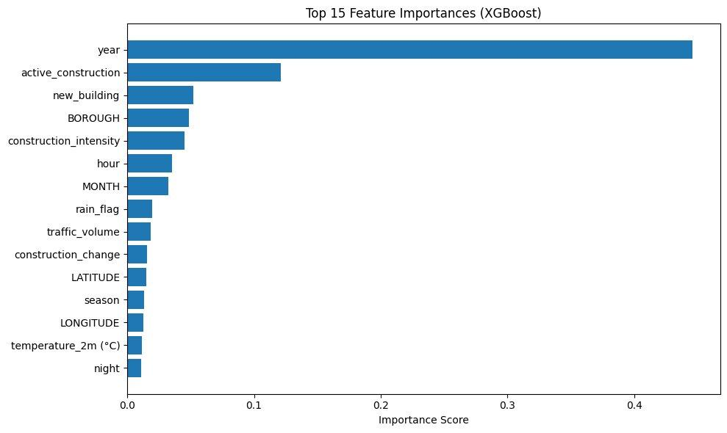
In order to understand which features are the most important to the model, the feature importance scores for the best performing model (XGBoost + scale_pos_weight) were extracted and displayed in Figure 6.2. All 31 input features have importance scores that have been displayed in this chart.

Figure 6.4.1: Feature importance scores for all 31 features - XGBoost + scale_pos_weight model.

Rank | Feature | Score | Category
1 | year | 0.4457 | Temporal
2 | active_construction | 0.1213 | Construction
3 | new_building | 0.0520 | Construction
4 | BOROUGH | 0.0487 | Spatial
5 | construction_intensity | 0.0450 | Construction
6 | hour | 0.0351 | Temporal
7 | MONTH | 0.0322 | Temporal
8 | rain_flag | 0.0198 | Weather
9 | traffic_volume | 0.0186 | Traffic
10 | construction_change | 0.0159 | Construction
Table 6.4.2: Top 10 most important features from XGBoost + scale_pos_weight model

6.5 Hyperparameter Tuning Results
The parameters for the model were optimised using a grid search with randomised input, with 3-fold cross-validation applied to the best performing model. Table 6.3 compares the base and tuned XGBoost models.
Metric | XGB Base | XGB Tuned | Change
ROC-AUC | 0.6602 | 0.6569 | -0.003
PR-AUC | 0.4009 | 0.3961 | -0.005
F1 | 0.4553 | 0.4521 | -0.003
Recall | 0.5613 | 0.5488 | -0.012
Precision | 0.3830 | 0.3844 | +0.001
Table 6.5: XGBoost base model vs hyperparameter-tuned model
The tuned model performed below the base model across most metrics (under 0.3% difference). This outcome is expected as tuning was conducted on a 200,000 record sample due to computational constraints. The negligible performance gap confirms the base model parameters were near-optimal. Full hyperparameter tuning on the complete training dataset is recommended for future work to further optimise model performance.

6.6 Confusion Matrix Analysis
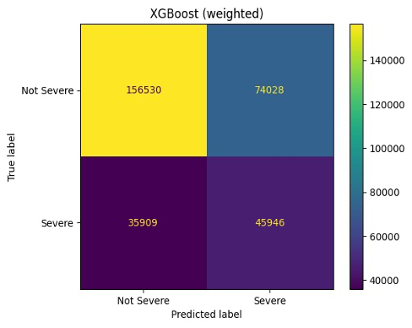
Figure 6.3 and Figure 6.4 present the confusion matrices for the base XGBoost model and the tuned XGBoost model respectively. The confusion matrix shows the number of True Positives (TP), True Negatives (TN), False Positives (FP), and False Negatives (FN) produced by each model on the test set of 312,413 records.
Figure 6.6.1: Confusion matrix — XGBoost + scale_pos_weight (base model)

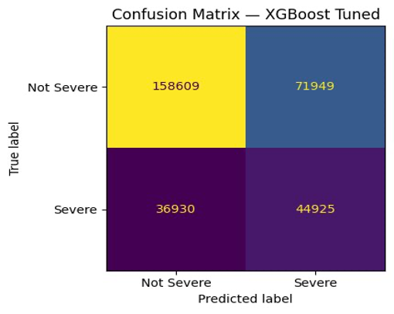
Figure 6.6.2: Confusion matrix — XGBoost Tuned

Both models show a similar pattern, a large number of True Negatives (156,530 and 158,609 respectively) and a moderate number of True Positives (45,946 and 44,925). The base model correctly identified 45,946 severe crashes while missing 35,909 (False Negatives). The tuned model identified slightly fewer severe crashes (44,925) but produced fewer False Positives (71,949 vs 74,028), indicating marginally higher precision. Both models struggle with the inherent difficulty of detecting severe crashes from contextual features alone, which is reflected in the relatively high False Negative counts.

7. Discussion
This section compares the results from the experiments with the results from the analysis of the road network data and discusses the findings in relation to the research questions raised in the study and the body of knowledge regarding traffic crash severity prediction models.

7.1 Model Comparison and Best Model Selection
For all six models tested, XGBoost with scale_pos_weight=2.82 performed best across all metrics with particular dominance on the most important metrics of this study (ROC-AUC: 0.6602, PR-AUC: 0.4009, F1-score: 0.4553). The model correctly identified 45,946 severe crashes out of 81,855 in the test set. It failed to detect 35,909 severe crashes (False Negatives).
The performance difference between XGBoost (0.6602) and Logistic Regression (0.6412) implies that XGBoost’s sequential boosting approach is able to capture the non-linear relationships present in the data. The moderate to low ROC-AUC scores achieved in this study (0.59–0.66) reflect the difficulty in predicting crash severity from external factors without additional information such as driver behaviour, vehicle and road characteristics.

7.2 Effect of Class Imbalance Handling
We find that, contrary to typical experience with SMOTE as opposed to class weighting methods, class weighting leads to well balanced results for all three algorithms, with the best result coming from the simple Learning Ratio + class_weight technique with a Recall of 0.5677. SMOTE however causes extreme overfitting. This was demonstrated on a limited sample of 200,000 records. Even then, both Random Forest and XGBoost learned poor ROC-AUC, with the models in fact predicting that nearly all crashes would be severe, with Random Forest achieving a Recall of 0.9928 and an ROC-AUC of 0.5161, while XGBoost achieved Recall of 0.9812 with an ROC-AUC of 0.5089.
The low performance observed is consistent with known limitations when employing SMOTE to non-representative subsets of large data. In this case, synthesising additional samples from a 200k record subset does not generalise well to the remainder of the 1.2m row training set. This experience supports the use of class weighting for large imbalanced learning problems and suggests that applying SMOTE to a sufficiently large, representative training set is critical to obtaining fair decision boundaries.

7.3 Feature Importance Findings
We present an in-depth feature importance analysis that provides insights to address the study’s research questions regarding the effects of time-of-day, weather, and environmental and built features on overall crash severity.
Time features are the most important set of predictors in the model, accounting for 44.6% of the variability in the data, with year being the strongest feature at 44.6%. This is due in large part to the dramatic changes in crash severity in NYC from year to year. The impact of the COVID-19 pandemic in 2020, which saw traffic volumes dramatically decrease for several months, is particularly evident. Other time features, including hour (3.5%), month (3.2%), and night (1.1%), also performed well in predicting crash severity, confirming results from other studies that find that when a crash occurs is a strong predictor of severity.
When comparing the relative importance of built environment features in predicting traffic crash severity, features that describe construction activity in the road environment are found to dominate. Active construction (12.1%), new building permits (5.2%), construction intensity (4.5%), and construction change (1.6%) together account for more than 22% of the total feature importance. This result provides insight into how features of the built environment that surround where crashes occur affect severity outcomes and addresses one of this study’s research questions. The finding has practical implications for urban traffic management; areas with construction can be viewed as high-risk locations where lowering speed limits, enhanced signage, and enforcement can reduce the severity of crashes that do occur.
Compared to demographics, spatial and traffic factors played a relatively limited role. Borough (4.9%) and spatial coordinates (2.7%) to be significant, indicating that there are differences across the five NYC boroughs in the impact of crashes. This difference likely results from factors related to road features, traffic, and response time. The factor of traffic volume (1.9%) confirms prior research that, on average, severe crashes occur in more densely trafficked locations.
Weather factors contribute but are secondary. Rain flag (2.0%) and temperature (1.1%) demonstrate that some weather conditions do influence crash severity, but to a lesser extent than temporal and construction factors. This is somewhat surprising given the intuitive relationship between weather and road safety, and may suggest that drivers in NYC adjust their behaviour in response to visible weather conditions.

7.4 Limitations
Several limitations of this study should be acknowledged:
- For the SMOTE methods, SMOTE oversampling was performed on a reduced 200,000 record subsample rather than on the full training set due to computational constraints which may have introduced some overfitting for these methods. Full SMOTE on the complete training set may yield different results.
- Hyperparameter tuning was performed on a sample of 200,000 records from the full data and the optimal model for the large data set may differ from the performance observed on the trained model.
- The existing features only include contextual factors (temporal, weather, construction, spatial) and important predictive factors such as driver behaviour, vehicle condition and road design are not considered.
- Traffic data is only reported at the borough level, which can be imprecise as conditions within a single borough can differ dramatically.
- Although this work has some limitations, it shows how a robust machine learning workflow can be used to analyse a real-world dataset to achieve predictive understanding of how severe a traffic crash will be, which can guide the deployment and allocation of resources for traffic safety and urban planning policies and practices.

8. Conclusion
This paper examined the risk of traffic injuries in New York City based on an integrated model that involves crash, weather, traffic and construction data. The findings confirm that crash risk is influenced by multiple interacting factors. The temporal patterns indicated that there is a high crash rate during peak hours, and the severity is high at night. Rain and snow weather conditions were found to increase the risk of injuries, and the volume of traffic was found to have a positive non-linear relationship with crash occurrence. Construction activity also added to local disruptions, which is important to note in terms of infrastructure-related factors.
A machine learning pipeline was constructed consisting of 31 engineered features that are used to predict the severity of a crash. Three models were trained and tested using the various class imbalance strategies, i.e. Logistic Regression, Random Forest, and XGBoost models. XGBoost using the class weighting (scale pos weight) method had the best overall performance. Conversely, SMOTE-based models resulted in overfitting because of sampling constraints whereas Logistic Regression offered a great base but failed at the non-linear relationship.
Overall, the results demonstrate that integrating diverse data sources with advanced machine learning models improves the prediction of traffic injury risk. This approach enables the identification of high-risk conditions and supports proactive, data-driven traffic safety interventions and urban planning strategies.

9. Group Work and Individual Contributions

9.1 Group Work
This proposal was done as a team effort and all the team members shared the responsibilities to achieve the purpose of efficient and balanced workflow. All members were involved in important modules in the project such as data collection, preprocessing, exploratory data analysis, feature engineering, modelling, and documentation.
The data cleaning and standardization and amalgamation of various data sets were considered as the data preprocessing phase which necessitated coordination in order to ensure consistency amongst sources of data. The engineering of features and forming models activities were conducted in a collaborative manner, and they were assisting in the development of meaningful features, control of the imbalance among classes, and performance of the model.
To implement the project, we developed Google Colab and Deepnote as our main coding environments and could effectively work with vast amounts of data and distribute progress. Communication and coordination were exercised via Microsoft Teams where we were able to discuss issues, provide updates and keep all the processes within the project on track.
All in all, the project can be regarded as a good cooperation process when all members worked on both technical and analytical sides of the work.
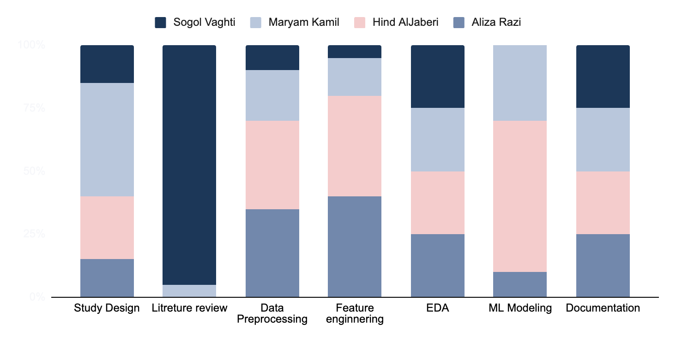

9.2 Individual Contribution: Maryam Kamil (2882517)
Data Cleaning and Preprocessing: I was primarily responsible for merging multiple datasets into a unified analytical dataset. This included cleaning the data, standardization of formats (mostly date, time and borough), missing values, and consistency of all sources. The matching of datasets between time and space resolved was especially focused on the preparation of the data in order to model it.
Feature Preparation for Modelling: I also helped in making features necessary in the modelling stage, such as making sure that variables were organised appropriately and that they were compatible with machine learning pipelines. This involved aiding the incorporation of traffic and construction features and making the data set complete and suitable to be analyzed.
Modelling Support (Verification and Validation): In the modelling process, I helped by cross-checking and verifying the modelling process. This involved checking of inputs, checking of outputs and consistency of preprocessing and modelling. This step helped ensure the reliability and correctness of the implemented models.
Report Writing and Collaboration: I also worked on the project documentation and wrote and organized parts that pertained to data preprocessing and methodology. During the project, I was in close contact with the members of the team, ensuring smooth integration of all components and alignment with overall project objectives.

9.3 Individual Contribution: Aliza Razi (3049919)
Data Cleaning and Preprocessing:I handled the cleaning and preprocessing of two real-life datasets, which were the Motor Vehicle Collisions Dataset (NYC Open Data) and the Traffic Volume Dataset (NYC DOT). This included managing of missing data, normalisation of data representations, and providing both datasets to be analytically prepared to be used in further modelling and exploration.
Crash vs Traffic Feature Engineering: I designed features which included a combination of crash records and traffic volume data, which allowed cross-dataset comparison of the association between traffic volume and frequency of collision in New York City.
Borough Imputation using KNN: In order to handle the 439,752 missing BOROUGH values in the collisions dataset, I implemented a KNN based imputation processor using geographic coordinates (LATITUDE, LONGITUDE) as predictors. There was an 80/20 train-validation split on the known-borough subset which produced a validation of 99.56 percent using a KNeighborsClassifier (k=5). The high accuracy very close to perfection can be explained by the fact that NYC boroughs are geographically non-overlapping polygons, so that latitude/longitude is nearly a completely deterministic predictor of membership in the borough. It was possible to recover all the 439,752 missing values.
Report Writing: I was also involved in the project report writing, which included the description of the preprocessing process, the way of imputation, result of the validation and the choice of feature engineering and exploratory data analysis in the corresponding sections. This also involved explaining the reasoning behind engineered features, also it was documented the patterns observed in the frequency of crashes, their severity and the effect of contributing factors that was discovered in the EDA process.

9.4 Individual Contribution: Sogol Vaghti (2725519)
I was primarily responsible for the data analysis and modelling components of the project, as well as the formatting and structuring of the presentation and final report.
My contributions included the data preprocessing and integration phase, where multiple datasets (traffic crash, weather, traffic volume, and construction data) were cleaned, standardized, and merged into a unified dataset. This involved handling missing values, aligning temporal variables, and applying K-Nearest Neighbors (KNN) to estimate missing spatial information.
I also conducted the exploratory data analysis (EDA), focusing on identifying temporal, environmental, and spatial patterns in crash injuries. Based on these insights, I developed key features for modelling, including temporal, environmental, spatial, and traffic-related variables.
In addition, I contributed to designing the modelling approach and preparing the dataset for predictive analysis. Finally, I ensured that both the presentation and final report were clearly structured, consistent, and professionally formatted.

9.5 Individual Contribution: Hind Aljaberi (2517184)
My main focus throughout this project was data modelling, which I led from the start . This includes everything from selecting and engineering some features, to training and evaluating six different model configurations through three algorithms “ Logistic Regression, Random Forest, and XGBoost” . I also handled the class imbalance problem using both SMOTE and class weighting techniques, ran hyperparameter tuning, and analysed the feature importance results to understand what actually drives crash severity in NYC.
Beside the modelling work, I also contributed to the data preprocessing stage, specifically cleaning and preparing the weather and construction datasets. This included dealing with missing values, standardising formats, and making sure both datasets were ready to be merged with the rest of the data. I also carried out the EDA on the construction data, which helped us understand how construction activity varies across boroughs and time periods before we move into modelling.
On the team side, I took part in the group discussions in shaping the research question, helped set up the Deepnote environment that the whole team used as our shared workspace, and contributed to the documentation throughout the project. Like any group project, a lot of the work happened through ongoing conversations and shared decisions, and I was an active part of that throughout.

10. References
New York City Department of Transportation. (2026). Motor vehicle collisions – crashes [Dataset]. NYC Open Data. https://data.cityofnewyork.us/Public-Safety/Motor-Vehicle-Collisions-Crashes/h9gi-nx95/about_data
Open-Meteo. (n.d.). Historical weather API documentation. https://open-meteo.com/en/docs/historical-weather-api?start_date=2016-01-01&hourly=&daily=weather_code,temperature_2m_mean,temperature_2m_max,temperature_2m_min,precipitation_sum,rain_sum,snowfall_sum,precipitation_hours,sunrise,sunset,daylight_duration,sunshine_duration&timezone=America%2FNew_York&latitude=40.7143&longitude=-74.006
New York City Department of Transportation. (2025). Automated traffic volume counts [Dataset]. NYC Open Data. https://data.cityofnewyork.us/Transportation/Automated-Traffic-Volume-Counts/7ym2-wayt/about_data
New York City Department of Buildings. (2026). DOB job application filings [Dataset]. NYC Open Data. https://data.cityofnewyork.us/Housing-Development/DOB-Job-Application-Filings/ic3t-wcy2/about_data

Perrels, A., Votsis, A., Nurmi, V., & Pilli-Sihvola, K. (2015). Weather conditions, weather information and car crashes. ISPRS International Journal of Geo-Information, 4(4), 2681–2703. https://doi.org/10.3390/ijgi4042681
Black, A. W., & Mote, T. L. (2015). Effects of winter precipitation on automobile collisions, injuries, and fatalities in the United States. Journal of Transport Geography, 48, 165–175. https://doi.org/10.1016/j.jtrangeo.2015.09.007
Das, S., Barua, S., & Hossain, A. (2025). Unraveling the complex relationship between weather conditions and traffic safety. Journal of Transportation Safety & Security, 17(5), 572–611. https://doi.org/10.1080/19439962.2024.2435307
Sadeghi, P., & Goli, A. (2024). Investigating the impact of pavement condition and weather characteristics on road accidents (Review paper). International Journal of Crashworthiness, 29(6), 973–989. https://doi.org/10.1080/13588265.2024.2348269
Tang, X., Liu, Z., & Wei, Z. (2024). Relationship between urban traffic crashes and temporal/meteorological conditions: Understanding and predicting the effects. Multimodal Transportation, 3, 100175. https://doi.org/10.1016/j.multra.2024.100175
Liu, C., & Sharma, A. (2017). Exploring spatio-temporal effects in traffic crash trend analysis. Analytic Methods in Accident Research, 16, 104–116. https://doi.org/10.1016/j.amar.2017.09.002
Pulugurtha, S. S., & Mahanthi, S. S. B. (2015). Assessing spatial and temporal effects due to a crash on a freeway through traffic simulation. Transportation Research Procedia, 10, 739–748.
Dai, D. (2012). Identifying clusters and risk factors of injuries in pedestrian–vehicle crashes in a GIS environment. Accident Analysis & Prevention, 45, 104–115. https://doi.org/10.1016/j.aap.2011.11.007
Hassandokht Mashhadi, A., Rashidi, A., Medina, J. C., & Marković, N. (2025). A hybrid framework for predicting crash severity in construction work zones using knowledge distillation and conditional GANs. Journal of Computing in Civil Engineering, 39(2), 04025010. https://doi.org/10.1061/JCCEE5.CPENG-6043
Vyas, T., & Varia, H. R. (2023). Impact of construction work zone on urban traffic environment. International Journal on Smart Sensing and Intelligent Systems, 16(1). https://doi.org/10.2478/ijssis-2023-0005

11. Deepnote Link
https://deepnote.com/workspace/HindAljaberi-ddb3c9b6-232e-4f90-b895-8798fdd25e64/project/Environmental-and-Temporal-Drivers-of-Traffic-Injury-Risk-in-NYC-e897d330-6e47-4227-a502-d5d7e90a2692?utm_content=e897d330-6e47-4227-a502-d5d7e90a2692

